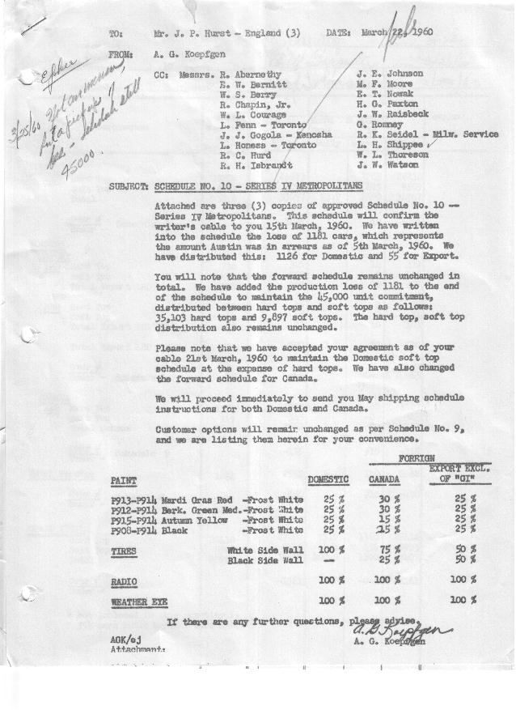

FORM AM 1262 Page 1 of 2 APPROVED R. Abernethy (signed) DATE 3-23-60

SCHEDULE NO. ______10 ___ DATE 3-22-60 MONTHLY BUILDING SCHEDULE APPROVED E.W.Bernitt (signed) DATE_ 3/23/60 _
REVISION NO. _______ __ ____ DATE PRODUCT APPROVED R. W.Chapin Jr. (signed) DATE _ 3/23/60 ____
SERIES IV 1500 c.c. ENGINE
METROPOLITAN SERIES CARS – AUSTIN MOTORS CO., LTD, ENGLAND
DESCRIPTION | BUILT  ACT◻ EST  THRU  Mar. 5 ‘60 | FIRM BUILDING SCHEDULE  (FABRICATED MATERIAL RELEASE) |  |  |  |  |  |  |  |  |  |  |  |  |  |  | TENTATIVE SCHEDULE  (RAW MATERIAL RELEASED) |  |  | GRAND  TOTAL
DESCRIPTION | BUILT  ACT◻ EST  THRU  Mar. 5 ‘60 | MONTH Balance of March  DAYS 19 |  |  | MONTH APRIL  DAYS 19 |  |  | MONTH MAY  DAYS 22 |  |  | MONTH JUNE  DAYS 20 |  |  | MONTH JULY  DAYS 16 |  |  | MONTH AUGUST  DAYS 18 |  |  | GRAND  TOTAL
DESCRIPTION | BUILT  ACT◻ EST  THRU  Mar. 5 ‘60 | DAILY | MONTH | CUM’L  TOTAL | DAILY | MONTH | CUM’L  TOTAL | DAILY | MONTH | CUM’L  TOTAL | DAILY | MONTH | CUM’L  TOTAL | DAILY | MONTH | CUM’L  TOTAL | DAILY | MONTH | CUM’L TOTAL | GRAND  TOTAL
DOMESTIC LHD:
Hard-Top | 18809 |  | 1434 | 20243 |  | 989 | 21232 |  | 1260 | 22492 |  | 1404 | 23896 |  | 1077 | 24973 |  | 1265 | 26238
Soft-Top | 5069 |  | 600 | 5669 |  | 791 | 6460 |  | 805 | 7265 |  | 456 | 7721 |  | 363 | 8084 |  | 425 | 8509
Total U.S. | 23878 | 107.1 | 2034 | 25912 | 93.7 | 1780 | 27692 | 93.9 | 2065 | 29757 | 93.0 | 1860 | 31617 | 90.0 | 1440 | 33057 | 93.9 | 1690 | 34747
Over/(Under) Schedule 9 |  |  |  | (1126) |  | 50 | (1076) |  | 50 | (1026) |  | 35 | (991) |  | (10) | (1001) |  | (10) | (1011)
FOREIGN:
EXPORT LHD Hard-Top | 236 |  | 13 | 249 |  | 14 | 263 |  | 14 | 277 |  | 14 | 291 |  | 14 | 305 |  | 14 | 319
Soft-Top | 72 |  | 6 | 78 |  | 6 | 84 |  | 6 | 90 |  | 6 | 96 |  | 6 | 102 |  | 6 | 108
Total Export LHD | 308 |  | 19 | 327 |  | 20 | 347 |  | 20 | 367 |  | 20 | 387 |  | 20 | 407 |  | 20 | 427
RHD Hard Top | 31 |  | 6 | 37 |  | 7 | 44 |  | 7 | 51 |  | 7 | 58 |  | 7 | 65 |  | 7 | 72
Soft Top | 14 |  | 2 | 16 |  | 3 | 19 |  | 3 | 22 |  | 3 | 25 |  | 3 | 28 |  | 3 | 31
Total Export RHD | 45 |  | 8 | 53 |  | 10 | 63 |  | 10 | 73 |  | 10 | 83 |  | 10 | 93 |  | 10 | 103
Total Export LHD & RHD | 353 | 1.4 | 27 | 380 | 1.6 | 30 | 410 | 1.4 | 30 | 440 | 1.5 | 30 | 470 | 1.9 | 30 | 500 | 1.7 | 30 | 530
Over/(Under) Schedule 9 |  |  |  | (55) |  | -0- | (55) |  | -0- | (55) |  | -0- | (55) |  | -0- | (55) |  | -0- | (55)
CANADA Hard-Top | 1354 |  | 18 | 1372 |  | 35 | 1407 |  | 60 | 1467 |  | 110 | 1577 |  | 130 | 1707 |  | 80 | 1787
Soft-Top | 147 |  | 98 | 245 |  | 55 | 300 |  | 45 | 345 |  | -0- | 345 |  | -0- | 345 |  | -0- | 345
Total Canada | 1501 | 6.1 | 116 | 1617 | 4.7 | 90 | 1707 | 4.7 | 105 | 1812 | 5.5 | 110 | 1922 | 8.1 | 130 | 2052 | 4.4 | 80 | 2132
Over/(Under) Schedule 9 |  |  |  | -0- |  | (50) | (50) |  | (50) | (100) |  | (35) | (135) |  | 10 | (125) |  | 10 | (115)
Total Foreign | 1854 | 7.5 | 143 | 1997 | 6.3 | 120 | 2117 | 6.1 | 135 | 2252 | 7.0 | 140 | 2392 | 10.0 | 160 | 2552 | 6.1 | 110 | 2662
Over/(Under) Schedule 9 |  |  |  | (55) |  | (50) | (105) |  | (50) | (155) |  | (35) | (190) |  | 10 | (180) |  | 10 | (170)
GRAND TOTALS
Hard-Top | 20430 | 77.4 | 1471 | 21901 | 55.0 | 1045 | 22946 | 60.9 | 1341 | 24287 | 76.8 | 1535 | 25822 | 76.8 | 1228 | 27050 | 75.9 | 1366 | 28416
Soft-Top | 5302 | 37.2 | 706 | 6008 | 45.0 | 855 | 6863 | 39.1 | 859 | 7722 | 23.2 | 465 | 8187 | 23.2 | 372 | 8559 | 24.1 | 434 | 8993
Total | 25732 | 114.6 | 2177 | *27909 | 100.0 | 1900 | 29809 | 100.0 | 2200 | 32009 | 100.0 | 2000 | 34009 | 100.0 | 1600 | 35609 | 100.0 | 1800 | 37409
Over/(Under) Schedule 9 |  |  |  | (1181) |  | -0- | (1181) |  | -0- | (1181) |  | -0- | (1181) |  | -0- | (1181) |  | -0- | (1181)
* Not included in this quantity is approximately 353 cars built March 1 thru March 5

FORM AM 1262 Page 2 of 2 APPROVED R. Abernethy (signed) DATE 3-23-60

SCHEDULE NO. ______10 ___ DATE 3-22-60 MONTHLY BUILDING SCHEDULE APPROVED E.W.Bernitt (signed) DATE_ 3/23/60 _
REVISION NO. _______ __ ____ DATE PRODUCT APPROVED R. W.Chapin Jr. (signed) DATE _ 3/23/60 ____
SERIES IV 1500 c.c. ENGINE
METROPOLITAN SERIES CARS – AUSTIN MOTORS CO., LTD, ENGLAND
DESCRIPTION | BUILT  ◻ACT◻ EST  THRU | FIRM BUILDING SCHEDULE  (FABRICATED MATERIAL RELEASE) |  |  |  |  |  |  |  |  |  |  |  |  |  |  | TENTATIVE SCHEDULE  (RAW MATERIAL RELEASED) |  |  | GRAND  TOTAL
DESCRIPTION | BUILT  ◻ACT◻ EST  THRU | MONTH SEPTEMBER  DAYS 22 |  |  | MONTH OCTOBER  DAYS 21 |  |  | MONTH NOVEMBER  DAYS 22 |  |  | MONTH DECEMBER  DAYS 10.9 (21 Available) |  |  | MONTH  DAYS |  |  |  |  |  | GRAND  TOTAL
DESCRIPTION | BUILT  ◻ACT◻ EST  THRU | DAILY | MONTH | CUM’L  TOTAL | DAILY | MONTH | CUM’L  TOTAL | DAILY | MONTH | CUM’L  TOTAL | DAILY | MONTH | CUM’L  TOTAL | DAILY | MONTH | CUM’L  TOTAL | DAILY | MONTH | CUM’L TOTAL | GRAND  TOTAL
DOMESTIC LHD:
Hard-Top |  |  | 1654 | 27892 |  | 1673 | 29565 |  | 1956 | 31521 |  | 1000 | 32521
Soft-Top |  |  | 416 | 8925 |  | 287 | 9212 |  | 114 | 9326 |  | 51 | 9377
Total U.S. |  | 94.1 | 2070 | 36817 | 93.3 | 1960 | 38777 | 94.1 | 2070 | 40847 | 96.4 | 1051 | 41898
Over/(Under) Schedule 9 |  |  | (10) | (1021) |  | 45 | (976) |  | 10 | (966) |  | 1051 | 85
FOREIGN:
EXPORT LHD Hard-Top |  |  | 14 | 333 |  | 14 | 347 |  | 14 | 361 |  | 14 | 375
Soft-Top |  |  | 6 | 114 |  | 6 | 120 |  | 6 | 126 |  | 6 | 132
Total Export LHD |  |  | 20 | 447 |  | 20 | 467 |  | 20 | 487 |  | 20 | 507
RHD Hard Top |  |  | 7 | 79 |  | 7 | 86 |  | 7 | 93 |  | 7 | 100
Soft Top |  |  | 3 | 34 |  | 3 | 37 |  | 3 | 40 |  | 3 | 43
Total Export RHD |  |  | 10 | 113 |  | 10 | 123 |  | 10 | 133 |  | 10 | 143
Total Export LHD & RHD |  | 1.4 | 30 | 560 | 1.4 | 30 | 590 | 1.4 | 30 | 620 | 2.7 | 30 | 650
Over/(Under) Schedule 9 |  |  | -0- | (55) |  | -0- | (55) |  | -0- | (55) |  | 30 | (25)
CANADA Hard-Top |  |  | 100 | 1887 |  | 110 | 1997 |  | 100 | 2097 |  | 10 | 2107
Soft-Top |  |  | -0- | 345 |  | -0- | 345 |  | -0- | 345 |  | -0- | 345
Total Canada |  | 4.5 | 100 | 2232 | 5.3 | 110 | 2342 | 4.5 | 100 | 2442 | .9 | 10 | 2452
Over/(Under) Schedule 9 |  |  | 10 | (105) |  | (45) | (150) |  | 80 | (70) |  | 10 | (60)
Total Foreign |  | 5.9 | 130 | 2792 | 6.7 | 140 | 2932 | 5.9 | 130 | 3062 | 3.6 | 40 | 3102
Over/(Under) Schedule 9 |  |  | 10 | (160) |  | (45) | (205) |  | 80 | (125) |  | 40 | (85)
GRAND TOTALS
Hard-Top |  | 80.7 | 1775 | 30191 | 85.9 | 1804 | 31995 | 94.4 | 2077 | 34072 | 94.4 | 1031 | 35103
Soft-Top |  | 19.3 | 425 | 9418 | 14.1 | 296 | 9714 | 5.6 | 123 | 9837 | 5.6 | 60 | 9897
Total |  | 100.0 | 2200 | 39609 | 100.0 | 2100 | 41709 | 100.0 | 2200 | 43909 | 100.0 | 1091 | 45000
Over/(Under) Schedule 9 |  |  | -0- | (1181) |  | -0- | (1181) |  | 90 | (1091) |  | 1091 | -0-

